*[Mandelbrot Set – by Jonathan Coulton](http://www.youtube.com/watch?v=gEw8xpb1aRA)*

Pathological monsters! cried the terrified mathematician

Every one of them a splinter in my eye

I hate the Peano Space

and the Koch Curve

I fear the Cantor Ternary Set

The Sierpinski Gasket makes me wanna cry

* In 1899, Poincaré remarked on the proliferation of pathological functions, "Logic sometimes makes monsters…”
* In geometry, the Peano curve is the first example of a space-filling curve to be discovered, by Giuseppe Peano in 1890. Example: 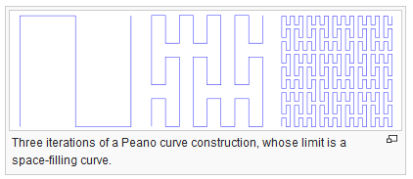
* The Koch curve fractal was first introduced in 1904 by Helge von Koch. It was one of the first fractal objects to be described.

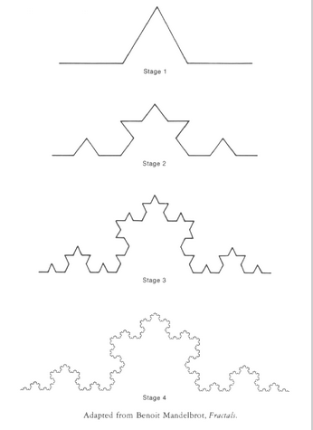

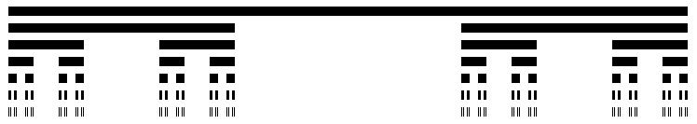

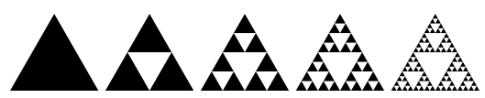

And a million miles away a butterfly flapped its wings

On a cold November day a man named Benoit Mandelbrot was born

His disdain for pure mathematics and his unique geometrical insights

Left him well equipped to face those demons down

He saw that infinite complexity could be described by simple rules

Used his giant brain and he turned the game around

And he looked below the storm

Saw a vision in his head

A bulbous pointy form

Picked his pencil up and he wrote his secret down

In chaos theory, the butterfly effect is the sensitive dependence on initial conditions in which a small change in one state of a deterministic nonlinear system can result in large differences in a later state. The name of the effect, coined by Edward Lorenz, is derived from the metaphorical example of the details of a hurricane being influenced by minor perturbations such as the flapping of the wings of a distant butterfly several weeks earlier.

The idea that one butterfly could eventually have a far-reaching ripple effect on subsequent historic events first appears in "A Sound of Thunder", a 1952 short story by Ray Bradbury about time travel.

Benoit B. Mandelbrot (20 November 1924 – 14 October 2010) was a Polish-born, French and American [mathematician](http://en.wikipedia.org/wiki/Mathematics), noted for developing a "theory of roughness" and "self-similarity" in nature and the field of [fractal geometry](http://en.wikipedia.org/wiki/Fractal_geometry) to help prove it, which included coining the word "fractal".

Emergent Behavior is another way of describing infinite complexity derived from simple rules.

Another reference to the butterfly effect.

A “Mandelbrot Set”: 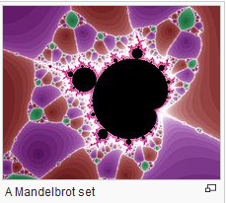

Just take a point called Z in the complex plane

Let Z1 be Z squared plus C

And Z2 is Z1 squared plus C

And Z3 is Z2 squared plus C and so on

If the series of Zs will always stay

Close to Z and never trend away

That point is in the Mandelbrot Set

Mandelbrot Set, you're a Rorschach Test on fire

You're a day-glo pterodactyl

You're a heart-shaped box of springs and wire

You're one badass fucking fractal

And you're just in time to save the day

Sweeping all our fears away

You can change the world in a tiny way

Mandelbrot's in heaven, at least he will be when he's dead

Right now he's still alive and teaching math at Yale

He gave us order out of chaos, he gave us hope where there was none

His geometry succeeds where others fail

So if you ever lose your way, a butterfly will flap its wings

From a million miles away, a little miracle will come to take you home

This is the algorithm to determine if a given point (x, y*i*) is in the Mandelbrot Set. In mathematical terms:

z 🡪 z2 + c

In words, iterate starting with a point z in the complex plane and a constant, generate a new z, and compute again. Note whether the sequence converges or diverges. If the former, it is in the Mandelbrot Set, otherwise it is not.

To construct a picture of a Mandelbrot Set, you compute the above recursive formula for every point z in a plane. The tradition is to color them black if they are in the Mandelbrot Set, and other colors depending on how many iterations it took to determine that the sequence is diverging. A Mandelbrot Set is a fractal.

A “Mandelbrot Zoom” is a Mandelbrot Set at closer and closer resolution, illustrating the self-similarity.

Mandelbrot died in 2010 at the age of 85.

Just take a point called Z in the complex plane

Let Z1 be Z squared plus C

And Z2 is Z1 squared plus C

And Z3 is Z2 squared plus C and so on

If the series of Zs will always stay

Close to Z and never trend away

That point is in the Mandelbrot Set

Mandelbrot Set, you're a Rorschach Test on fire

You're a day-glo pterodactyl

You're a heart-shaped box of springs and wire

You're one badass fucking fractal

And you're just in time to save the day

Sweeping all our fears away

You can change the world in a tiny way

And you're just in time to save the day

Sweeping all our fears away

You can change the world in a tiny way

Go on, change the world in a tiny way

Come on, change the world in a tiny way

Song by Jonathan Coulton <https://www.youtube.com/watch?v=gEw8xpb1aRA>